**Ideation Phase**

**Define the Problem Statements**

|  |  |
| --- | --- |
| Date | 8 September 2022 |
| Team ID | PNT2022TMID23587 |
| Project Name | Project – WEB PHISHING DETECTION |
| Maximum Marks | 2 Marks |

PROBLEM STATEMENT 1:

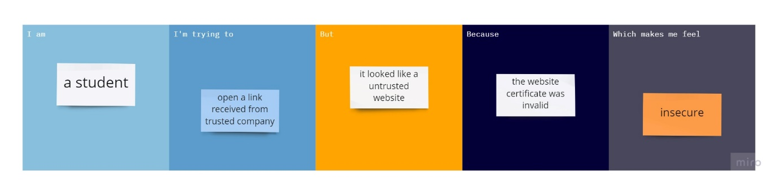

PROBLEM STATEMENT 2:

PROBLEM STATEMENT 3:

PROBLEM STATEMENT 4:

|  |  |  |  |  |  |
| --- | --- | --- | --- | --- | --- |
| **Problem Statement (PS)** | **I am (Customer)** | **I’m trying to** | **But** | **Because** | **Which makes me feel** |
| PS-1 | student | Open a link from a trusted company | It looked like a untrusted website | the website certificate was invalid | insecure |
| PS-2 | farmer | Check my balance | Claims that there was a problem in the account and asked for personal information | They wanted to confirm personal information inorder to steal the money | untrustworthy |
| PS-3 | homemaker | Purchase my new things online | Ended up purchasing from a fake website | The website has advertised with a fake discount | disappointed |
| PS-4 | Employee of a company | Complete my work | Received mail from boss regarding some work but the mail looked phishy | The url was not proper and the sender seems to be a fake one | disturbed |